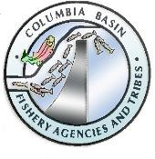 | FISH PASSAGE CENTER  847 NE 19th Avenue, #250, Portland, OR 97232  Phone: (503) 833-3900 Fax: (503) 232-1259  www.fpc.org/  e-mail us at fpcstaff@fpc.org

MEMORANDUM

To: Fish Passage Advisory Committee (FPAC) From: FPC Staff
Date: November 15, 2022

Subject: Falconry Notes and presentation from Sky Falconry at the November 15, 2022, FPAC meeting

Cfm Note: The discussion notes and the Sky Falconry slides were copied here from the final approved FPAC meeting notes for the FPOM Falconry Work Group

On November 15, 2022, FPAC met via conference call for its weekly meeting. The following people participated in the meeting:

Jonathan Ebel (FPAC Chair IDFG) Tom Lorz (FPAC Vice-Chair CRITFC) Brandon Chockley (FPC)
Charlie Morrill (WDFW) Dave Swank (USFWS) Erick Van Dyke (ODFW) Erin Cooper (FPC)
Gabe Scheer (FPC) Jay Hesse (NPT)
Kyle Dittmer (CRITFC)
Rachel Tessier (FPC) Tom Iverson (YN) Trevor Condor (NOAA)
Alina Blankenship (Sky Guardian Falconry Abatement)
Blaine Parker (CRITFC) Tom Skiles (CRITFC) Lindsey O'Halloran (FPC) Michele DeHart (FPC)

Falconry Abatement Presentation Alina Blankenship (Sky Guardian Falconry Abatement) and Blaine Parker (CRITFC) provided a presentation on Falconry Abatement (see attached PowerPoint and handout).
- Jonathan Ebel (IDFG) requested that FPAC determine whether to suggest that falconry be implemented at the projects and to determine Ahow it should be evaluated.
- Alina noted that the approach to falconry abatement is less food driven and more training oriented. Lethal take is not the goal.
- Dave Swank (USFWS) questioned what occurred on the days when the falcons weren't at the projects and how long it took for the gulls to react to the falcon or hawk's presence. Alina responded that each project has its own needs and timeline. She remarked that the birds do require some time to adjust to their environment before they can develop their confidence. Within a week, there will be discernible progress in gull removal. She noted that it is important to maintain a presence in order to have an on-going effects.
- Dave Swank enquired as to whether the effect persisted in the absence of a hawk. Alina retorted that their method of seeing results involves using lures or signals (i.e., force multipliers) to make birds think falcons are still present. She prefers to stay onsite for the first seven days of the contract to establish a presence, and then spread out her time during the duration of the contract. Since they employ force multipliers and the gulls remember the falcon's presence, it does work on off days, but it works best if you front load it. If the issue reappears, they return for a second full week.
- Dave Swank asked if the gulls would eventually acclimate to the whistles and attractants if you didn’t return with the hawks. Alina advised against using these passive strategies excessively.
- Jonathan questioned whether there would be a problem if the falcons were only present on some projects as opposed to all projects. Alina believes that if they continue to accost them metabolically, we can lower the success of the nesting process. They proposed GPS monitoring at TDA in 2023 to track around two dozen Gulls to see where they were going.
- Jonathan asked them to describe their interactions to date with the COE and the state as you understand it for this process moving forward. Alina responded TDA brought in a falconer for 5 days in 2021 to test the concept. In 2022, a pilot study was implemented, which lasted for 30 days. The COE is asking for 60 days in 2023.
- Dave Swank enquired as to whether it was correct that while the avian lines at JDA are made of a different substance than those at TDA, the birds there have problems seeing them. Alina responded yes, and the grid is much tighter. According to size, the project at TDA was the most challenging and required two falconers, she said. She noted that the wires are not a huge concern because they can utilize hawks instead of falcons.
- Jonathan noted that the COE is working on an RFQ for a 60-day study at TDA in 2023 but it is unclear at this time if MCN will have falconers in 2023.
- Trevor Condor (NOAA) stated that he is uneasy about the TDA evaluation and the prolonged delay for the response. He believed that the evaluation's findings did not conclusively prove that the falcons were able to accountable for the response; other factors may also have been involved.
- Blaine Parker (CRITFC) noted the data can be interrupted in a variety of ways, but you really need to see it in action. The birds do not “rubber-band” when a falcon is present, unlike with cannons. Given that the evaluation began in the middle of the season, there is some start-up time for the birds to become accustomed to the region to sufficiently reduce gulls foraging in the tailrace area. Alina added that acclimation to the area before the season begins would be extremely useful and result in the birds preforming better.
- Trevor wants reliable information so that he can decide whether to proceed with falcons in the future and noted his concern that these studies may delay the installation of wires at MCN, which is gaining momentum.
- Jay Hesse (NPT) asked if the falcons can be used in nesting areas rather than foraging areas. Blaine responded as long as there aren’t eggs on the ground and there’s no take you can.
- Tom Lorz (CRITFC) questioned whether we would adopt the tactic of utilizing a falcon only three days a week rather than seven, along with other passive steps to keep gulls that are scouting away. Is that the approach? Alina said she's seen success with that strategy, and Tom said it's crucial to consider how to trick the gulls into believing you're still around even when you're not. Alina agreed and said it would take some trial and error to see which methods worked best. One benefit of the falconry abatement is that it is adaptable and always changing; it is not a static operation. Jonathan noted that this complicates evaluating studies like this, as it is hard to evaluate a study is the signal is constantly changing. Blaine noted that falconry abatement is not static like wires and hazing. If you try to make it static for evaluation you will be frustrated. Wires and hazing are not working.
- Tom Lorz asked what the limitations are regarding weather. Alina responded they have a range of birds and tolerances so they’re able to adapt to most weather patterns.
- Jonathan pointed out that FPAC has the ability to recommend whether they support falconry abatement in 2023 and wants member’s input.
- Dave Swank responded that while he was interested in exploring the costs relative to wires, he wasn't sure if an FPAC recommendation was required because FPOM and FFDRWG were also looking at the matter. Dave also asked Blaine why he thinks the avian wires are not effective. Blaine noted that this comment was observational. Drive by and you see lots of gulls and pelicans in the tailraces. These are static devices that animals adapt to. If they were perfect, we wouldn’t be having this conversation.
- Charlie Morrill (WDFW) noted that this is a dynamic approach, not static, but questioned whether it is cost effective for the long term. Is it sustainable? Blaine noted that the wires at JDA cost $18 million and the estimate for wires at MCN is $6-9 million. According to the cost sheet (attached), you could do 4 months of abatement at all three projects with money from O&M, instead of a capital project. If FPAC can issue letter of support for 2023, seems it could be useful.
- Jay Hesse asked which forums have the actionable authority. He added that he’s concerned with just pushing birds around and more interested in a system wide application in order to solve the issue.
- Charlie noted that a system wide application is the goal but first implementation at MCN or JDA to see the results would be beneficial as well.
- Jay added that if the COE is already funding other forms of hazing, since someone has already approved this and he feels that the falcons shouldn’t be held to a higher standard than other forms of hazing. Trevor responded that since the discussion involved employing the falcons instead of the wires at MCN or whether we're going to have a system wide use of falconry at the projects, he believes the falcons should be held to a higher standard. He believes that we need solid proof (data) that this works. NOAA would be in favor of doing this in 2023, but there must be an evaluation that they deem appropriate and a research plan for the logistics.
- Jonathan noted from an IDFG perspective he doesn’t see this as replacing the wires at projects. The effectiveness comes from a lack of predictability, which makes an evaluation more difficult. To be able to have enough information on how the program functions, it needs to be done for a year at a project to see how it’s adaptively
implemented in response to prey behavior. He added that if we don’t make a recommendation, he could see the COE doing this piecemeal which wouldn’t be as beneficial as doing it for a set amount of time.
- Trevor agreed and feels like we need to spend some time critically thinking about the study design before it begins.
- Tom Lorz asked who FPAC should submit comments to. Jonathan responded Chris Peery and/or Steve Juhnke at the COE. Tom responded that it would be beneficial to submit comment to both Chris and Steve since the SCT budget is out and it would be hard to get funding through that channel.
- Jonathan noted that some agencies aren’t interested in pushing this forward, but IDFG is. He will take a shot at writing something and will share it with FPAC, even if it ends up being a letter of the willing.

These minutes have been reviewed and approved by the Fish Passage Advisory Committee.

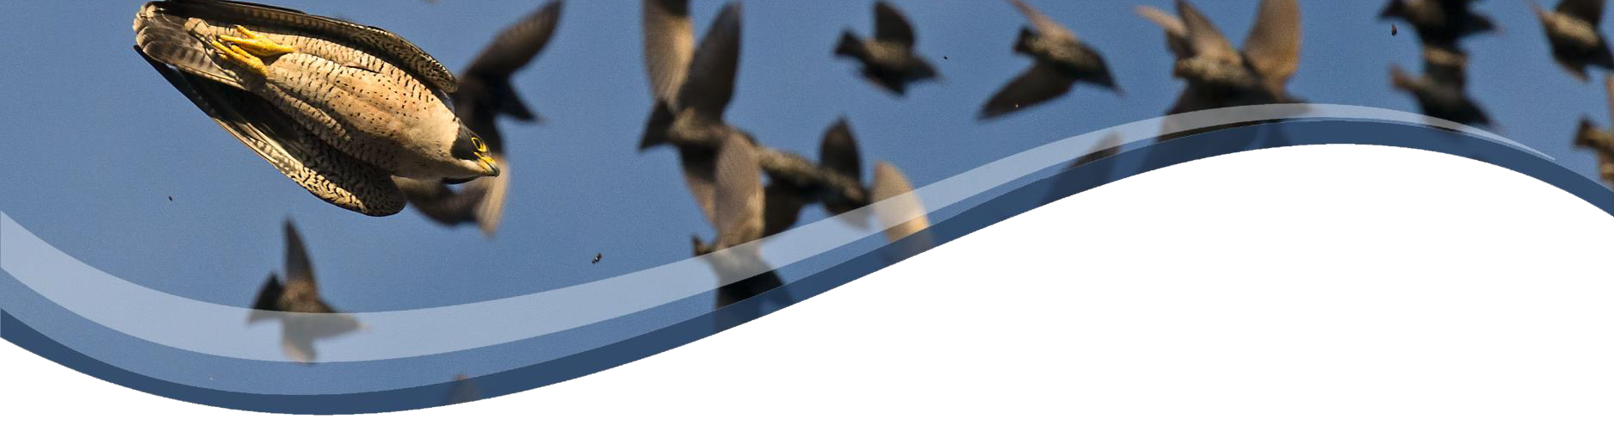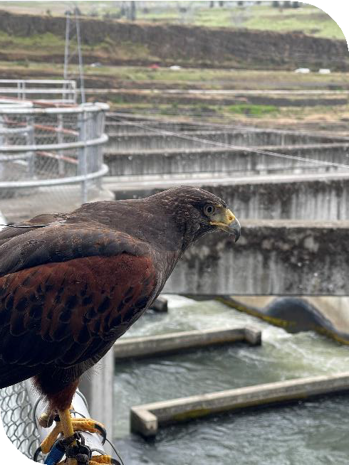

FALCONRY ABATEMENT LEVERAGES THE PREDATOR PREY RELATIONSHIP WHICH IS HARDWIRED IN THE BRAIN OF THE BIRD. THEY WILL NEVER ACCLIMATE.

THE NATURE OF THE BEAST: Understanding the Falcon, Falconry and Falconry Abatement
Falconry is a millennia old hunting sport of taking wild quarry with a trained
bird of prey. It delivers a lethal outcome.
Falconry Abatement is a subtle and strategic approach which takes advantage of the Natural predator prey dynamic. Falconry abatement is a hazing strategy of non-lethal engagement.

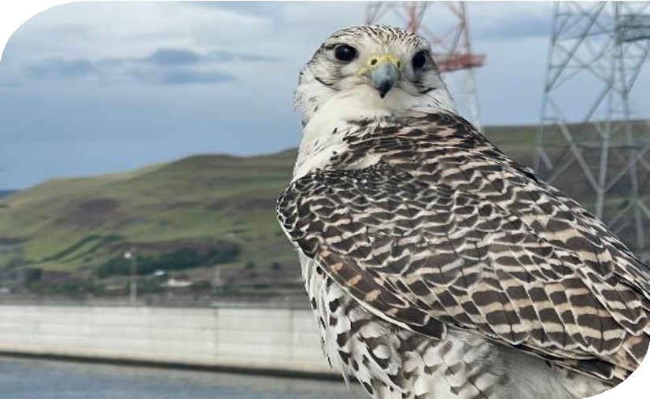

Falconers shape natural behaviors of the raptors with food rewards

Provide a genuine, non-relenting threat to the target species

Visible and vigilant show of lethal force for an enduring solution

Battle of attrition with increased annual effectiveness as many target birds will never return and they will teach their progeny of the perils

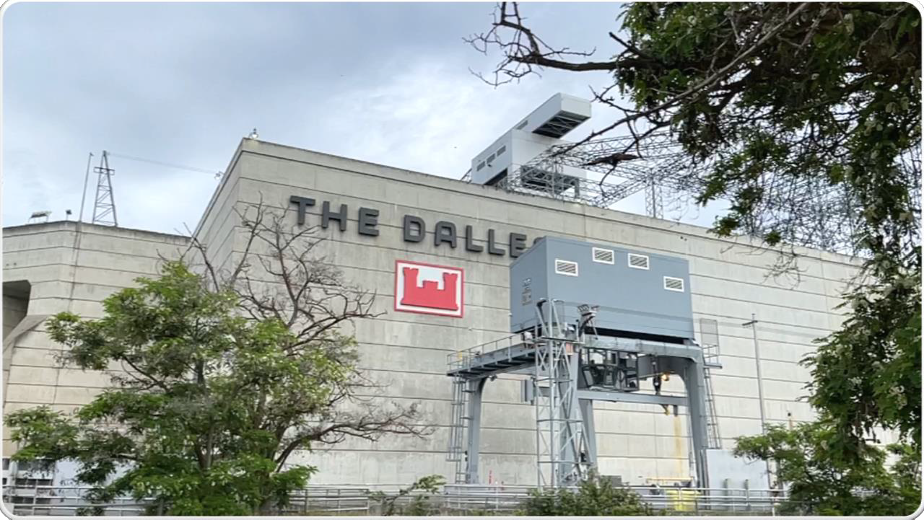

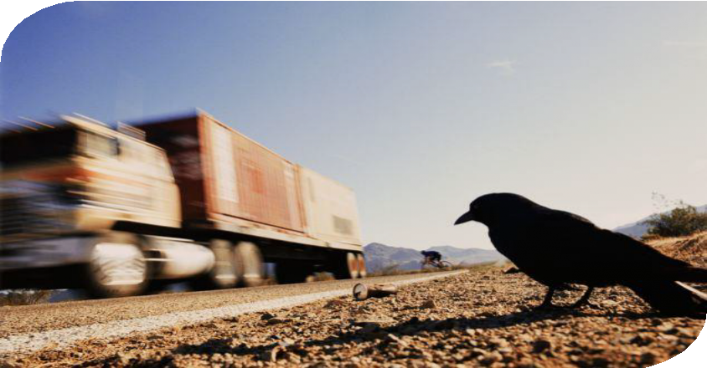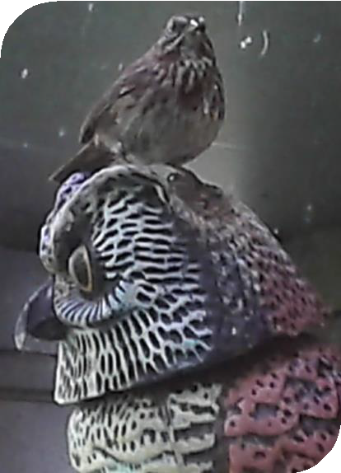FAKING IT: The Mimicry of Bobble Head Owl

Perception Matters - many birds see in the UV spectrum; while the silhouette may startle, upon further inspection, they see a pink poodle

Nothing Bad Happens – Noises and flashes are easily assimilated as simply a part of their environmental conditions

Threat Assessment Specialists – You are travelling 50 mph toward a crow feasting on road carrion. As you approach, the crow takes
two steps to the left to avoid collision

WILDLIFE SURVIVES BY ACCURATE PERCEPTION AND ASSESSMENT OF DANGER.

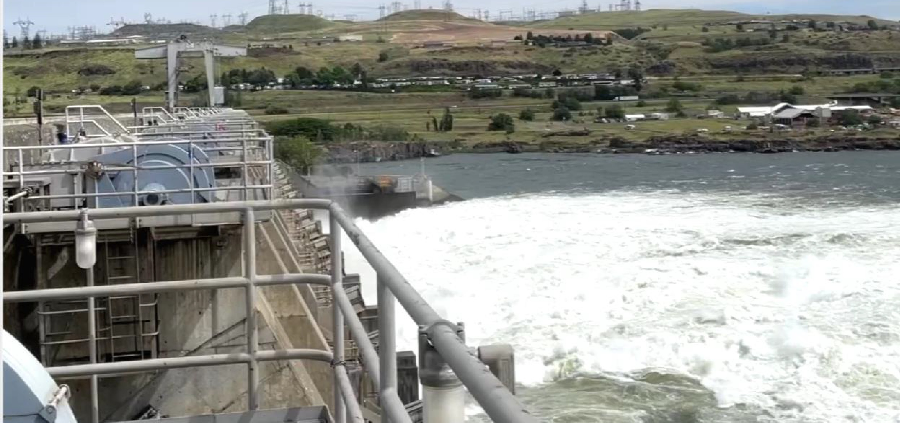

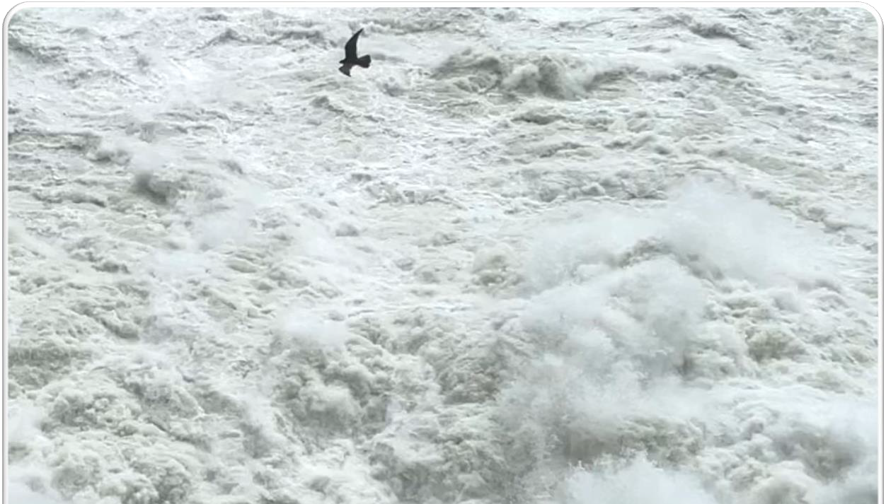

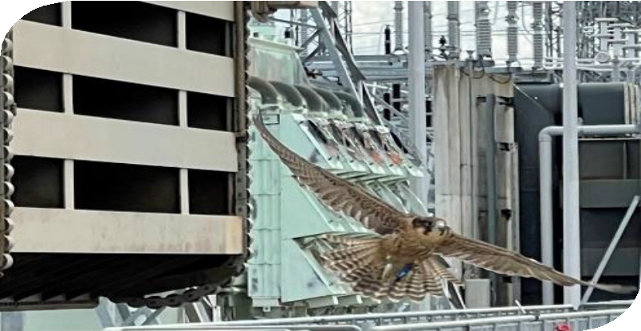UNPREDICTABLE and GENUINE: The Weapons of Falconry Abatement
Installed and daily use deterrents tend to be predictable and
become a feature of the habitat
The danger posed by falcons is persistent and UNPREDICTABLE. The raptors are actively hunting to kill and DO NOT BLUFF

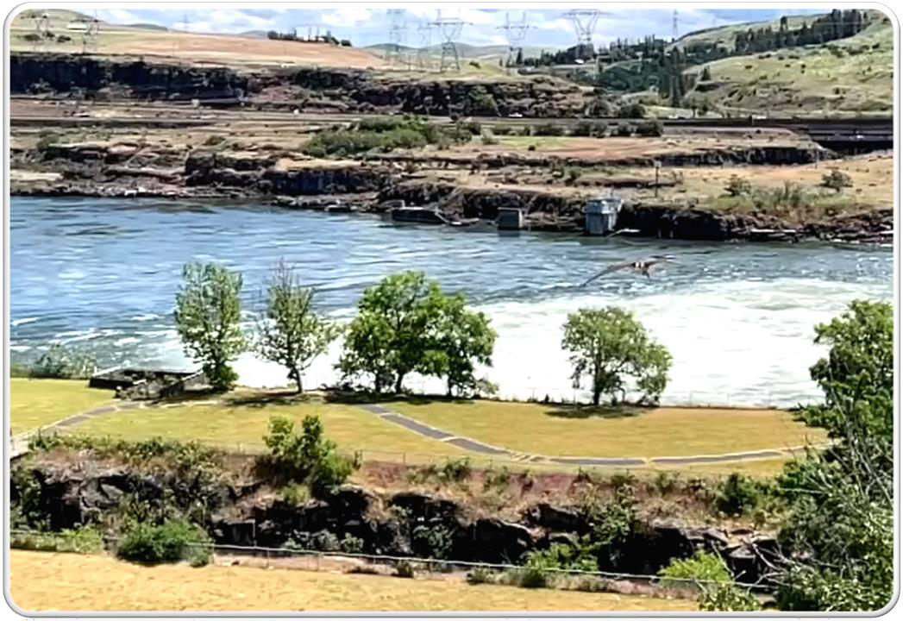

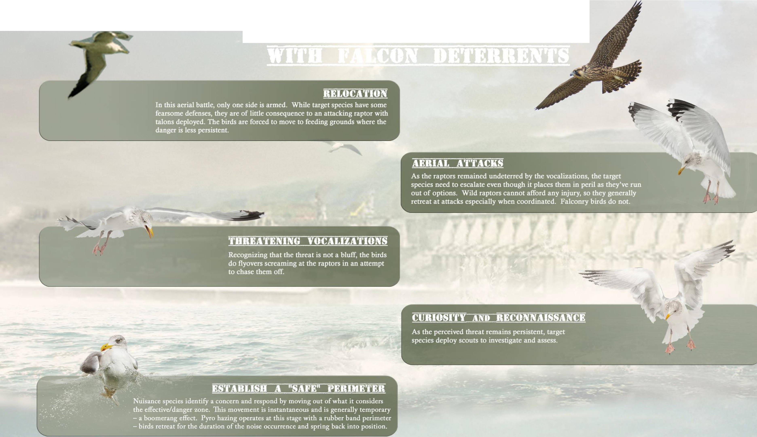

TARGET BEHAVIOR MODIFICATION

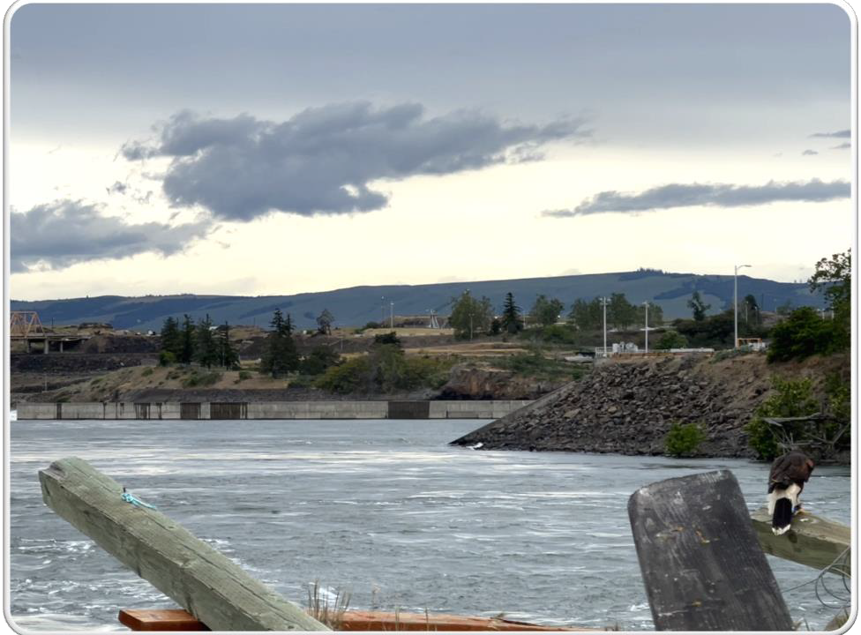

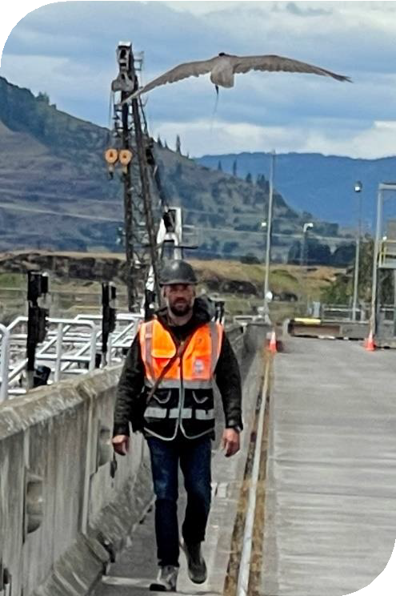

NO SILVER BULLETS: Limitations of Falconry Abatement

The Few - Professional Abatement Falconers are extremely limited; around 100 in the US

Wild Things - Although highly trained, abatement raptors are still wild animals and can be unpredictable and become injured or create undesired circumstances

It’s Complicated – Projects and facilities may have barriers to effectiveness such as avian lines, restricted access or extreme environments

One Size Does Not Fit All - Each target species will react differently to each of the raptors employed. It may take trial and error to find the best bird for each situation.

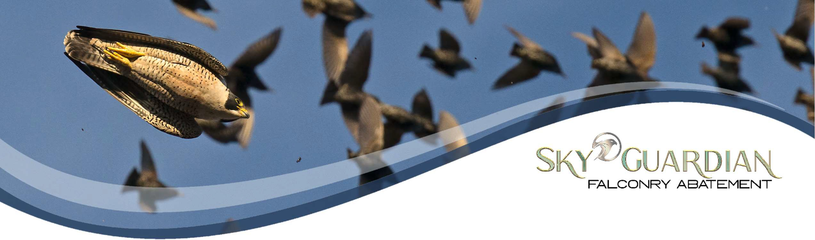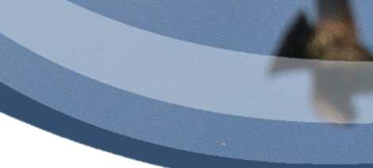

503.969.6119
www.SkyGuardianFalconry.com

Falconry Abatement Success for Challenging Operational Environments
Considerations and Strategies

THE NATURE OF THE BEAST: Understanding the Falcon, Falconry and Falconry Abatement

Falconry is a millennia old hunting sport of taking wild quarry with a trained bird of prey. It delivers a lethal outcome.

Falconry Abatement is a subtle and strategic approach which takes advantage of the natural predator prey dynamic. Falconry abatement is a hazing strategy of non-lethal engagement.
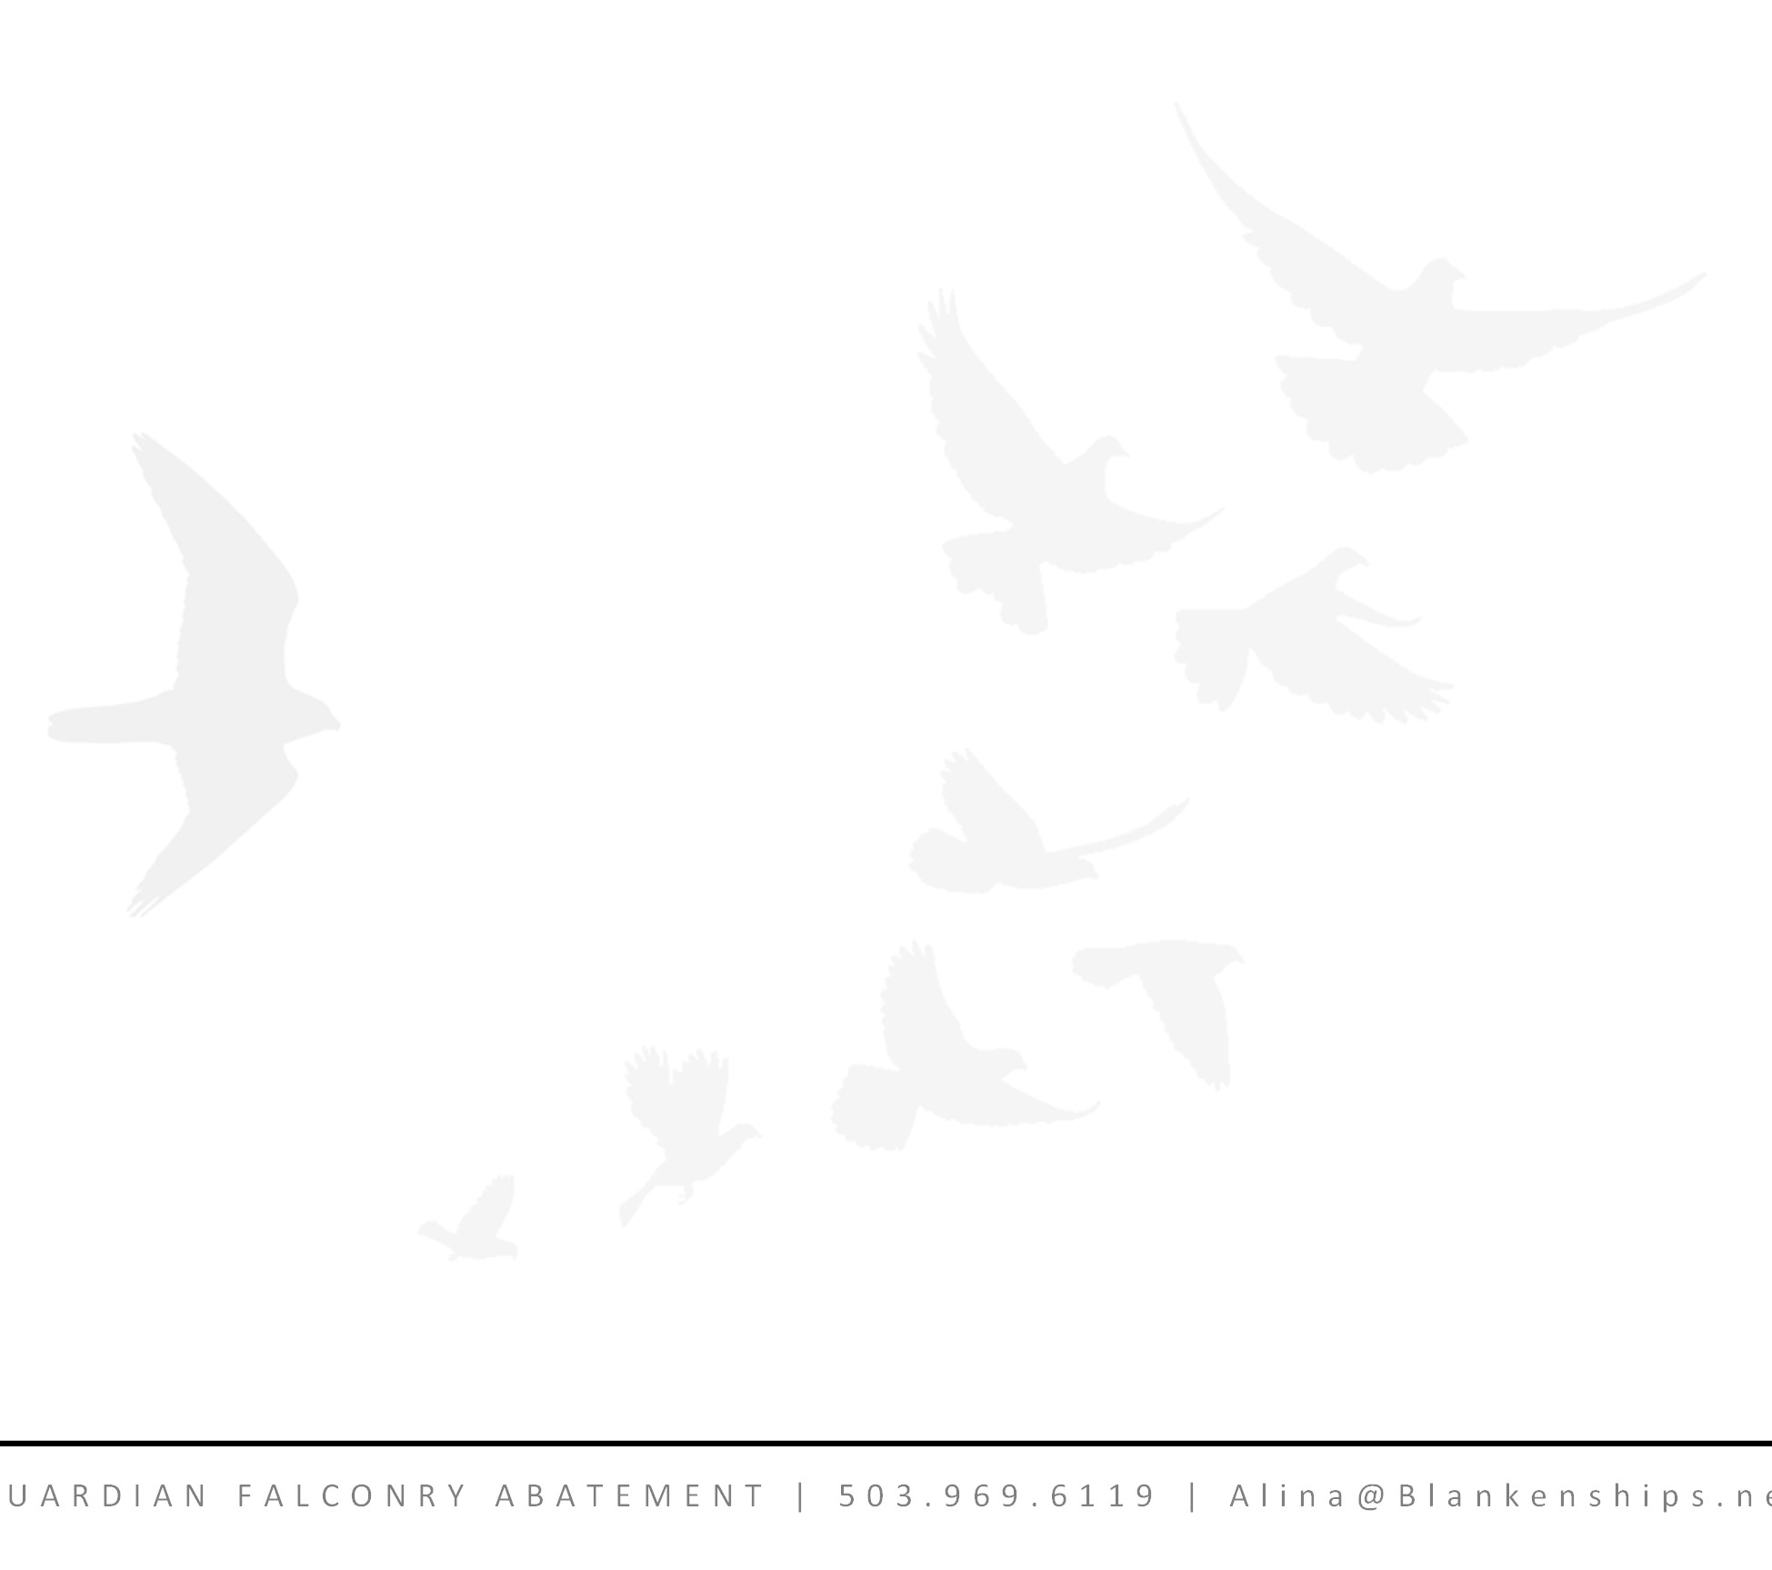Falconers shape the natural tendencies and behaviors of the raptors to provide a genuine, non-relenting threat to the target species. Not a guns blazing approach but a visible and vigilant show of lethal force
for an enduring solution. Falconry
abatement is a battle of attrition. A location

FALCONRY ABATEMENT LEVERAGES THE PREDATOR
PREY RELATIONSHIP WHICH IS HARDWIRED IN THE BRAIN OF THE BIRD. THEY WILL NEVER ACCLIMATE.
can expect increased effectiveness year over year as many target birds will never return and they will teach their progeny of the perils.

Falcons (and hawks) are intelligent and sensitive creatures each with unique personalities, skills and optimal operating conditions. Best results are obtained when the birds are given the time and opportunity to assess the potential dangers themselves cognitively rather than instinctually then dismiss them. Confident birds are created. The confidence of a falcon direct correlates to its effectiveness. Advance planning for contracts accommodates proper acclimation and availability of optimized raptor species for the conditions.
Birds naturally maintain a cycle of rest and action. When not in active pursuit or prospecting, raptors perch with a vantage prepared for explosive action at the opportunity of a potential meal. Thus, a perched abatement raptor remains a visible reminder of the existent threat - a trap that can be sprung at any moment. Available deterrent techniques are predictable. Falcons are UNPREDICTABLE. This is our greatest strength and the greatest difference from the existing strategies.

The nuisance species must make a calculation of cost and risk versus reward and for each individual there is a different threshold which is why the effort must be sustained.
S K Y G e t 1
U A R D I A N F A L C O N R Y A B A T E M E N T | 5 0 3 . 9 6 9 . 6 1 1 9 | A l i n a @ B l a n k e n s h i p s . n

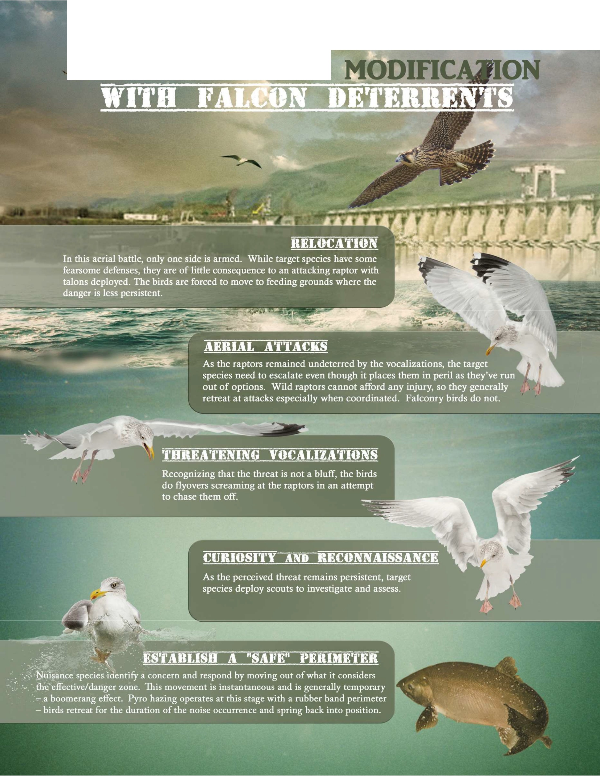•
TARGET BEHAYIOR

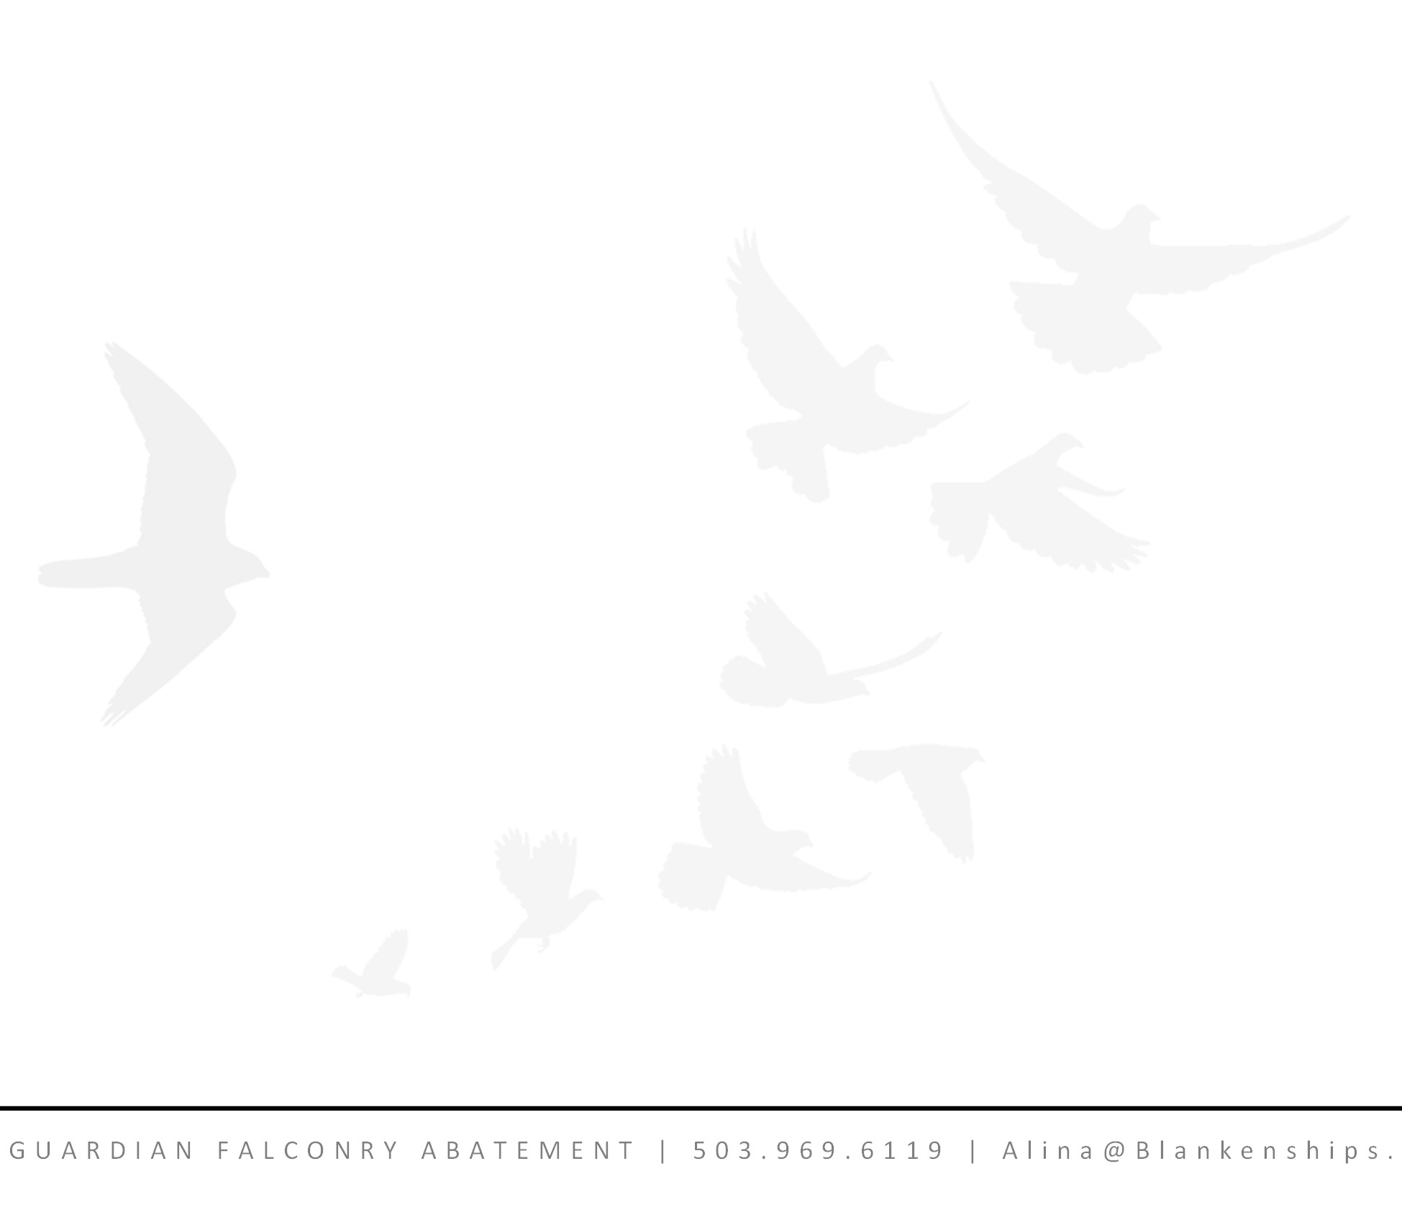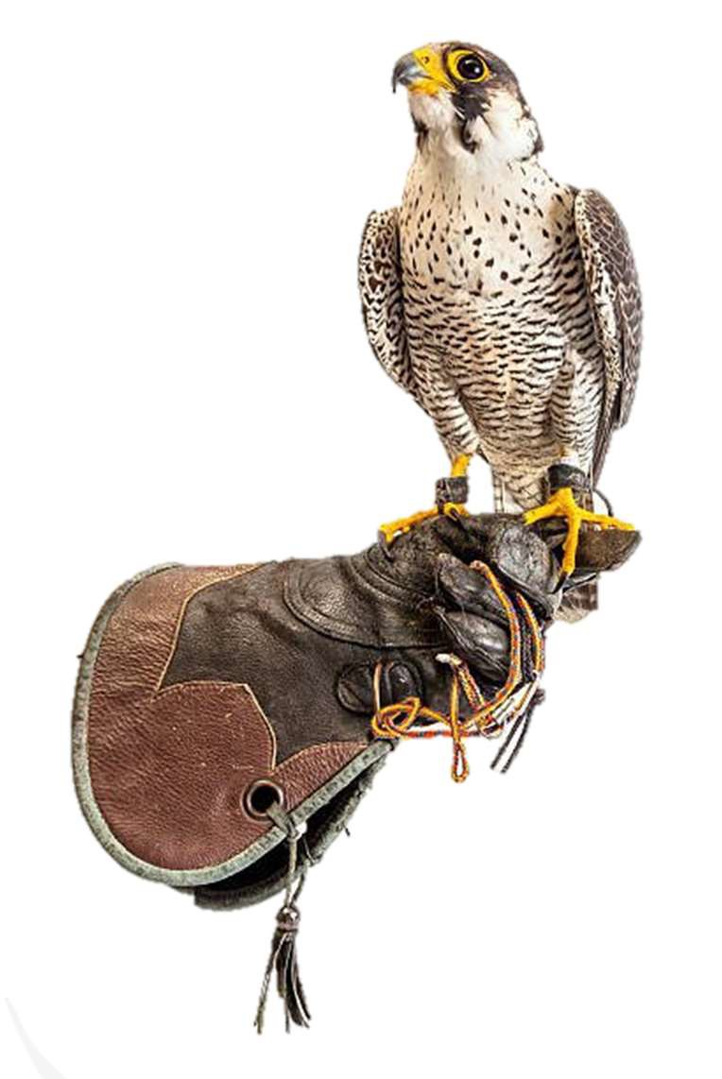CHOOSING WELL: Characteristics for evaluating Falconry Abatement Contractors

Falconers work many years to build their skill, capabilities and ability to navigate issues which arise. An outfit should have Master Falconers on site. It takes a minimum of 7 years to achieve the rank of Master Falconer. To deal with labor constraints, there is a temptation to place Apprentice falconers in situations for which they do not possess sufficient experience.
Operating in a complex and variable environment demands a Large and Diverse Team of Raptors. In a vibrant and dynamic environment with rapidly changing winds, temperatures, obstacles and target species, having a deep bench of varying species allows the falconer to apply the correct tool to the situation. An example of a diverse team might include 5-8 raptors such as Gyrfalcon, Saker Falcon, Peregrine Falcon, Aplomado Falcon, Goshawk and Harris’ Hawk.
To maximize safety and effectiveness, falconers should use the latest technology including GPS tracking systems for real time positioning in addition to the traditional Radio Telemetry Tracking.
Falconers who remain true to the roots of falconry abatement - the hunting sport of falconry – generally have raptors with lethal intent elevating the abatement activities from mere showmanship to a daily hunt.
Although Falconry abatement is highly effective compared to mimicry and passive strategies, companies should be skilled in the use of Force Multipliers, such as dogs, pyrotechnic acoustics, RC, and kites.
Licensing and skill in operating situation specific machinery and crafts such as boats, ATVs and lifts provide a substantial advantage as well.
As public image and interaction tend to be an important component of falconry efforts for a client, temperament matters for the falconers and their birds to operate safely around people and in the public eye. Falconers should demonstrate good command over their birds.

Experience Matters. Ask for the falconer’s experience in industrial situations, references and longevity of current and prior contracts. Agricultural clients can provide excellent insight as they maintain precise understanding of necessary costs and will not retain a falconer who does not provide good value.

S K Y n e t 3
G U A R D I A N F A L C O N R Y A B A T E M E N T | 5 0 3 . 9 6 9 . 6 1 1 9 | A l i n a @ B l a n k e n s h i p s .

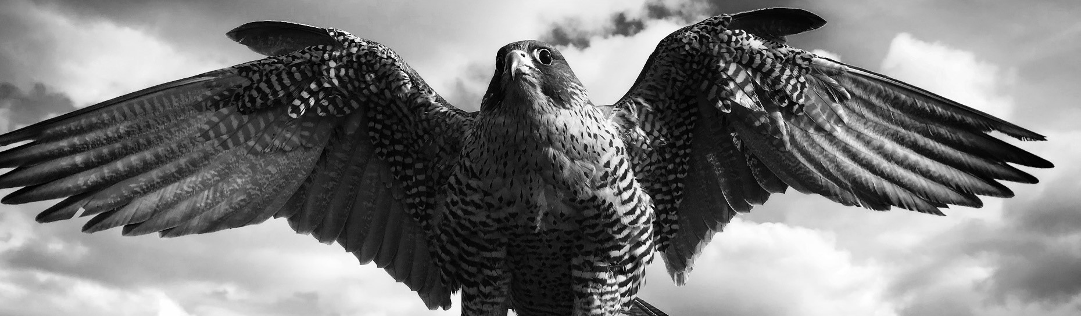THE COST OF MASTERY: Proposed costs for falconry abatement services
S K Y G U A R D I A N F A L C O N R Y A B A T E M E N T | 5 0 3 . 9 6 9 . 6 1 1 9 | A l i n a @ B l a n k e n s h i p s . n e t 4

Professional Abatement Falconers are a highly specialized service provider requiring years of training and experience. In America, there are only around 4500 sport falconers and of those, 150 are professional abatement falconers. Falconers must purchase, train, and maintain a team of specialized raptors and dogs.


As falconers are in high demand during peak season, sliding scale pricing can account for flight days spread out over longer calendar periods to compensate for missed contract days. Also, ala carte pricing allows for activities that forward the effort but represent a lower cost on those days.
As fuel prices and consumer costs continue to be erratic, costs may change before a contract is executed.
Lead Master Falconer $1000 - $1200/day For 30 flight days over 60 - $1200/day For 45 flight days over 60 - $1100/day For over 60 flight days - $1000/day
Secondary Falconer $700/day. Not generally necessary for the entire term of the contract. 50-75% of the contract days should suffice. Only applies to very large projects with multiple foraging zones.
Acclimation Days priced at $500/day - puts target birds on notice and familiarizes falcons with the location.
Hacking Days priced at $400/day – newly fledged birds provide all day coverage with few falconer labor hours. This must be arranged in advance to guarantee the availability of young birds.
Pyro Hazing $50/day for consumables
Boat Hazing $1300/day – will be captained by a falconer and will be available extended hours equivalent to the falconer’s work day. As permissible, the boat will be moored on or near project and will be deployed for active hazing as needed and will be available for the entire duration of falconer shifts.
Jet Ski Hazing $500/day –As permissible, a jet ski will be moored on or near project and will be deployed for active hazing as needed and will be available for the entire duration of falconer shifts.
A recommended contract term of 2 plus years takes advantage of the familiarity, institutional and situational knowledge gained by falconer and falcons.

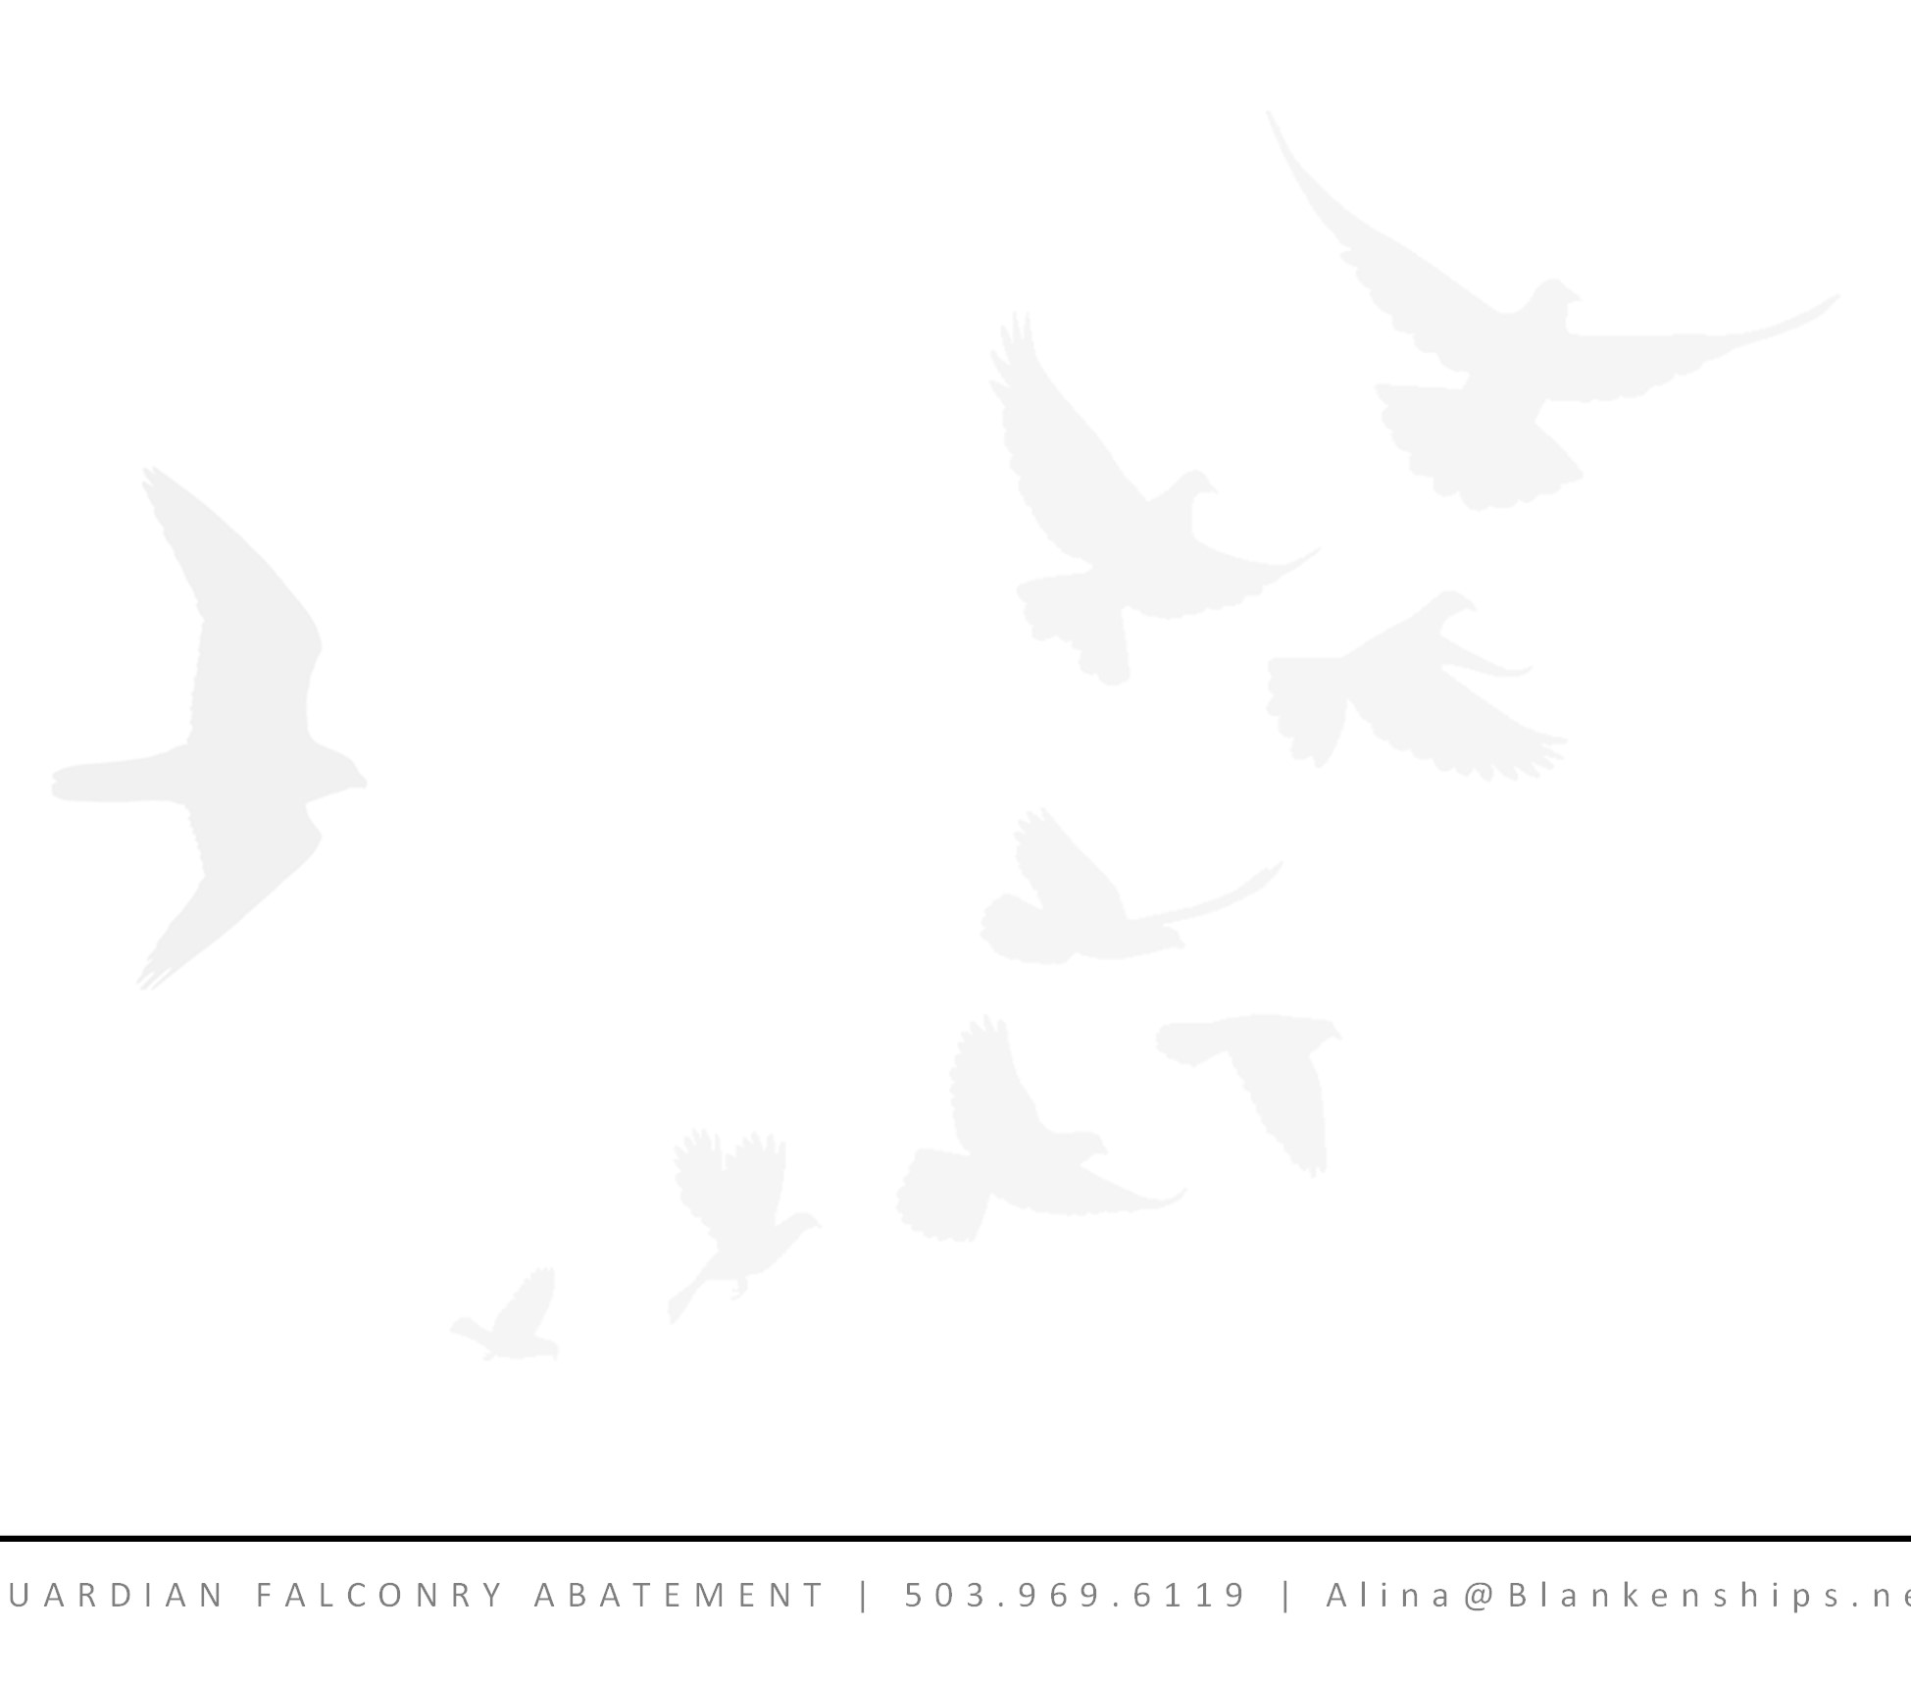

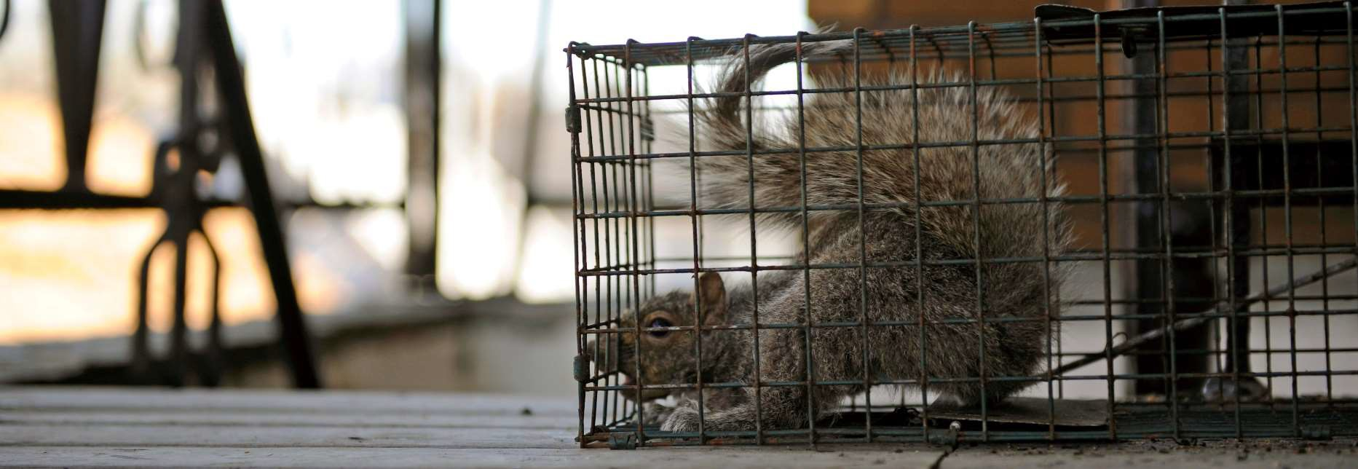
A COMPLETE SOLUTION: Our team possess diverse skills and licenses to resolve wildlife conflicts
Wildlife Control Operator services are available to trap and/or shoot nuisance mammalian species and secondary avian species, such as pigeons and starlings.
On projects where Lethal Take is approved, our team is comprised of licensed, extremely experienced and highly qualified trappers and shooters to satisfy that need.
These services are dependent on appropriate licenses and permissions from USFWS and other stakeholder agencies and individuals. We will work with contracting agencies to verify and acquire permits as necessary.
Costs to be determined based on the scope and scale.

As the avian battle is fought on many fronts, Bird Exclusion and Deterrent Products may deny resting and perching opportunities and support falconry efforts when falcons are not present. We are certified sellers and installers of some innovative products.
Our Avian Shock Track is a low-profile electrified track applied to flat perching surfaces which delivers a harmless but uncomfortable shock similar to a livestock fence or a dog training collar. The system can be powered by a solar unit so does not need to be located near a power source. A product that delivers consequence to the bird, not a bluff. We can sample a number of products on project to determine their efficacy.

To further offer no safe harbor, RC Boat and Aircraft can play a role. We are exploring the permissibility of the use of a 3D printed bald eagle RC aircraft and large RC boat and are working with agency security to approve each component and software. $1000 Annually.

Public Relations, Press and Community Outreach are important tools in supporting the sustainable and ecological approach of falconry abatement. We will do a town hall, school outreach or presser at no cost to educate and gain community support. $0

S K Y G e t 5
U A R D I A N F A L C O N R Y A B A T E M E N T | 5 0 3 . 9 6 9 . 6 1 1 9 | A l i n a @ B l a n k e n s h i p s . n


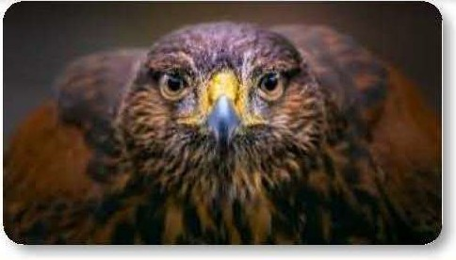
Sky Guardian, LLC, falconry-based nuisance bird abatement professionals, serve the Pacific Northwest with decades of experience. Anytime, anywhere nuisance birds are found - we offer a solution. With creativity, tenacity and adaptability as our forte, we are confident in our ability to resolve any problem presented.

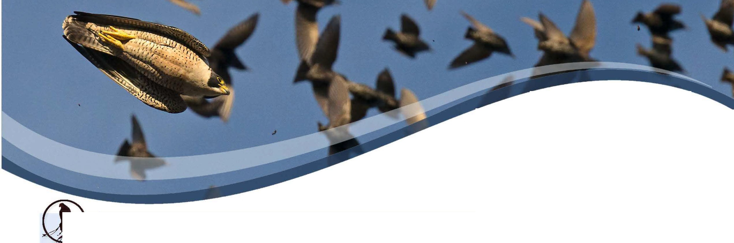CORE CAPABILITIES
S GUAJ\PIA
FALCONRY ABATEMENT & BIRD REMOVAL
ODFW UCENSED WILDLIFE CONTROL OPERATOR

503.969.6119
www.SkyGuardianFalconry.com
CAPABILITIES STATEMENT

Experienced Master Level Falconers
Successfully employing Falconry Based Avian Abatement in complex environments
Wildlife Control Operator licenses allow us to employ industry standard and unique strategies to deter wildlife to compliment the falconry
Extensive experience using nets and traps in large, busy enterprises as well as installation of exclusion products
Under our USFWS propagation license, we can breed falcons dedicated to specific contracts
 LICENSES/ CERTIFICATIONS HELD
ODFW Master Falconer
ODFW Wildlife Control Operator
USFWS Migratory Bird Special Purpose: Abatement USFWS Migratory Bird Special Purpose: Propagation USFWS Migratory Bird Special Purpose: Education USFWS Migratory Bird Special Purpose: Salvage USFWS Migratory Bird Special Purpose: Specimen FAA Approved Wildlife Hazard Management Training

PAST CLIENTS

Among our clients for whom we have resolved nuisance birds: US Army Corps of Engineers, Amazon, UPS, Walmart, Lowes, Safeway, Fred Meyer as well as for numerous commercial agricultural and industrial clients.
References available upon request.

CORPORATE DATA

UEI: QP3NBPAV6RH6 I CAGE: 954A4
WEBSITE: SkyGuardianFalconry.com
POC: Alina Blankenship
PHONE: 503.969.6119
EMAIL: Alina@Blankenships.net
ADDRESS: 25165 SW Pete's Mountain Road West Linn OR 97068
WORK AREA: OR, WA, CA ID
SOCIO-ECONOMIC STATUS: WOSB
NAICS:561710, 114210,115112,115310,813312
PAYMENT: Accept Credit Cards

DIFFERENTIATORS

Team of 25 raptors. A variety of species of hawk and falcon offer variably of flight styles and specialties which allow us to apply the correct "tool" for every circumstance
Force Multipliers - Highly trained dogs and pyrotechnics working with the raptors multiply the effectiveness; RC
Our strategy of "hacking" young falcons on contract site builds a specialized predator from the ground up. Raising them on site gives them the home court advantage of learning the winds and the environment
Extensive Media, Public Relations and Educational Experience encourages public support, conveying the humane and sustainable nature of this approach
Competency in operating marine craft in a variety of demanding situations
With the most current GPS and radio telemetry technology, we constantly track our birds in real-time

